SEMESTER TWO
Papers written by Australian Maths Software

YEAR 12
MATHEMATICS SPECIALIST
UNIT 3-4, REVISION ONE
2016
Section Two
(Calculator–assumed)

Name: _________________________________

Teacher: ________________________________

TIME ALLOWED FOR THIS SECTION

Reading time before commencing work: 10 minutes
Working time for section: 100 minutes

MATERIAL REQUIRED / RECOMMENDED FOR THIS SECTION

To be provided by the candidate
Standard items: pens, pencils, pencil sharpener, highlighter, eraser, ruler.
Special items: drawing instruments, templates, notes on up to two unfolded sheet of A4 paper, and up to three calculators approved for use in the WACE examinations.

IMPORTANT NOTE TO CANDIDATES
No other items may be taken into the examination room. It is your responsibility to ensure that you do not have any unauthorised notes or other items of a non–personal nature in the examination room. If you have any unauthorised material with you, hand it to the supervisor before reading any further.

To be provided by the supervisor
Question/answer booklet for Section Two.
Formula sheet retained from Section One.
Structure of this examination

 | Number of questions available | Number of questions to be answered | Working time (minutes) | Marks available | Percentage of exam
Section One  Calculator—free | 8 | 8 | 50 | 2 | 35
Section Two  Calculator—assumed | 12 | 12 | 100 | 98 | 65
Total marks |  |  |  | 150 | 100

Instructions to candidates

1. The rules for the conduct of this examination are detailed in the Information Handbook. Sitting this examination implies that you agree to abide by these rules.

2. Write your answer in the Question/Answer booklet.

3. You must be careful to confine your responses to the specific questions asked and to
follow any instructions that are specific to a particular question.

4. Spare pages are provided at the end of this booklet. If you need to use them, indicate in the original answer space where the answer is continued i.e. give the page number.

5. Show all your working clearly. Your working should be in sufficient detail to allow your answers to be checked readily and for marks to be awarded for reasoning. Incorrect answers given without supporting reasoning cannot be allocated any marks. For any question or part question worth more than two marks, valid working or justification is required to receive full marks. If you repeat an answer to any question, ensure that you cancel the answer you do not wish to have marked.

6. It is recommended that you do not use pencil, except in diagrams.

7. The Formula Sheet is not to be handed in with your Question/Answer booklet.

9. (4 marks)

(a) Find the vector equation of the line perpendicular to the plane 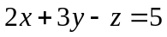
and that contains the point 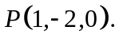 (1)

(b) Given the two planes defined by
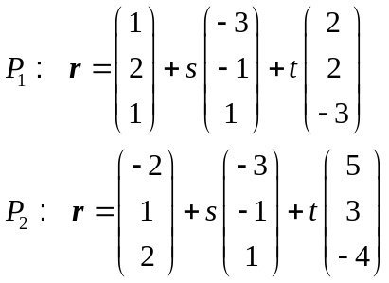
Explain how to determine if the two planes define two identical planes. (3)

10. (5 marks)

A little boy, holding a sandwich in his hand at (0, 0, 0.5), is running along the street such that the position vector of the sandwich is 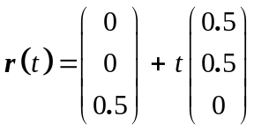 where is measured in seconds from 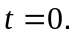

A kookaburra at 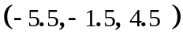 eyed off the sandwich for one second then swooped down with a velocity of 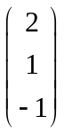 to pinch the sandwich.
(a) Show that the position vector of the kookaburra from  is
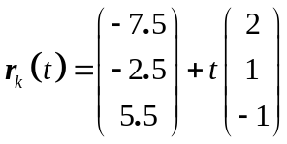. (1)

(b) How fast did the kookaburra fly? Distances are measured in metres. (1)

(c) How many seconds does the kookaburra take to steal the sandwich (not
including the second when the bird is eyeing off the sandwich). (3)

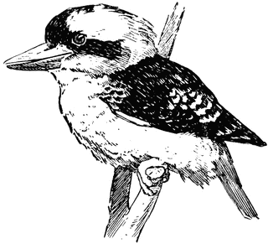

11. (4 marks)
Find the area enclosed by the functions 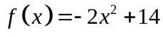 and 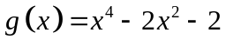. (4)

12. (8 marks)
Use De Moivre’s theorem to prove that 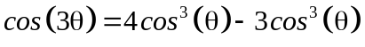 (6)

(b) Calculate 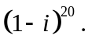 (2)

13. (17 marks)
Consider the functions 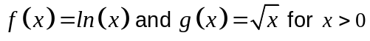.
(a) (i) Determine the expression for 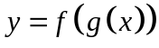and explain why the function is
defined. (2)

(ii) Explain why the function has an inverse. (1)

(iii) Find the equation of the inverse of the function . (3)

(b) (i) Find the domain such that the function 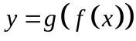 exists. (3)

(ii) Determine whether the function 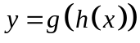 is a one to one function given
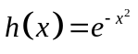. (3)

(c) (I) Given 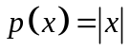 sketch 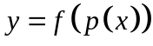 on the set of axes below. (3)

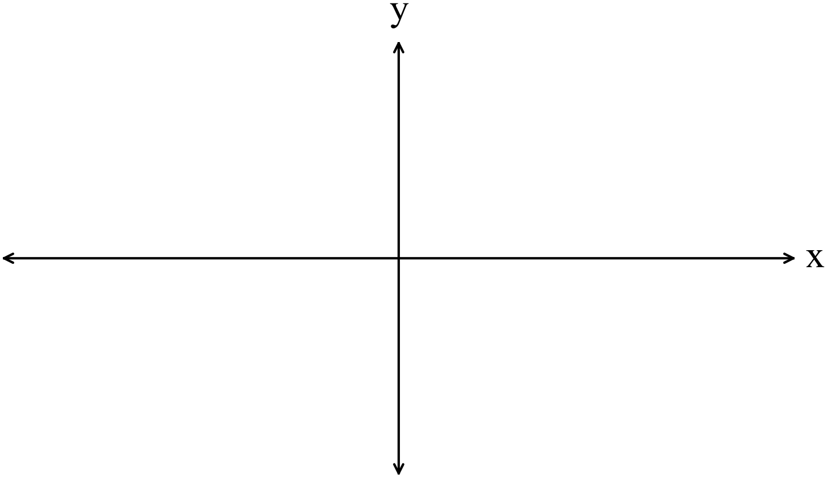

(ii) Find 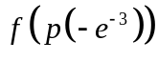 (2)

14. (10 marks)
The function 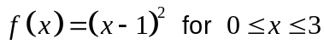 is rotated about theaxis.
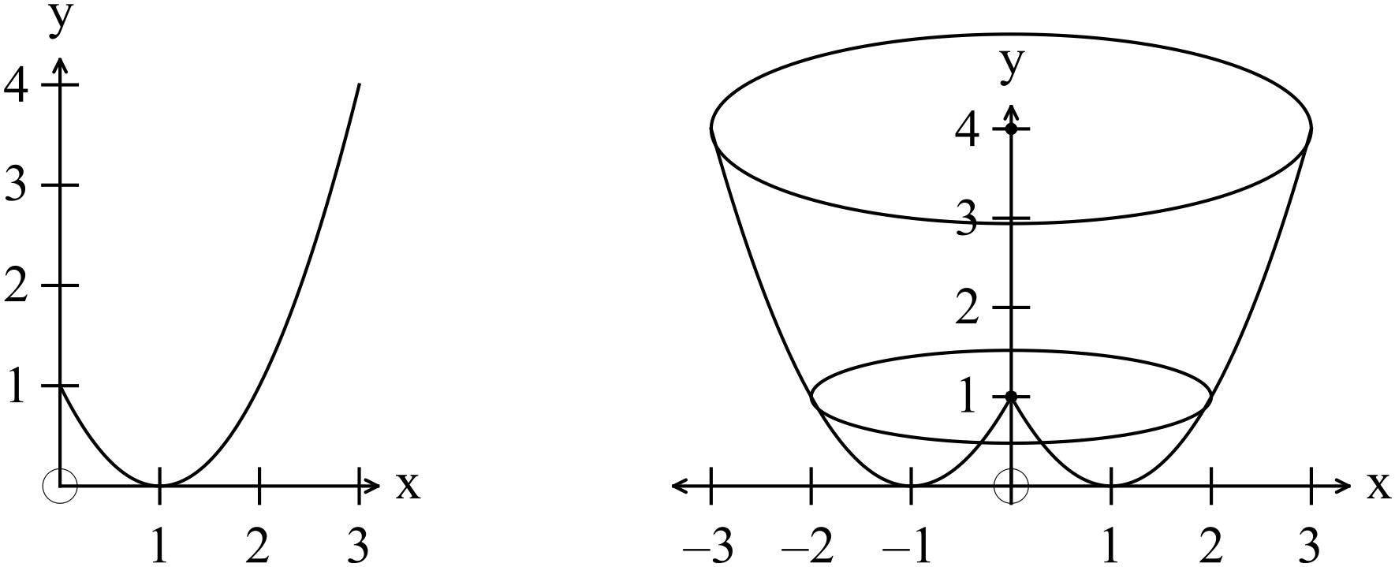
(a) Find the generated volume. (5)

(b) Determine the volume to a height of 1 m. (1)

(c) Find the height that gives a volume of 22.5 units³. (4)

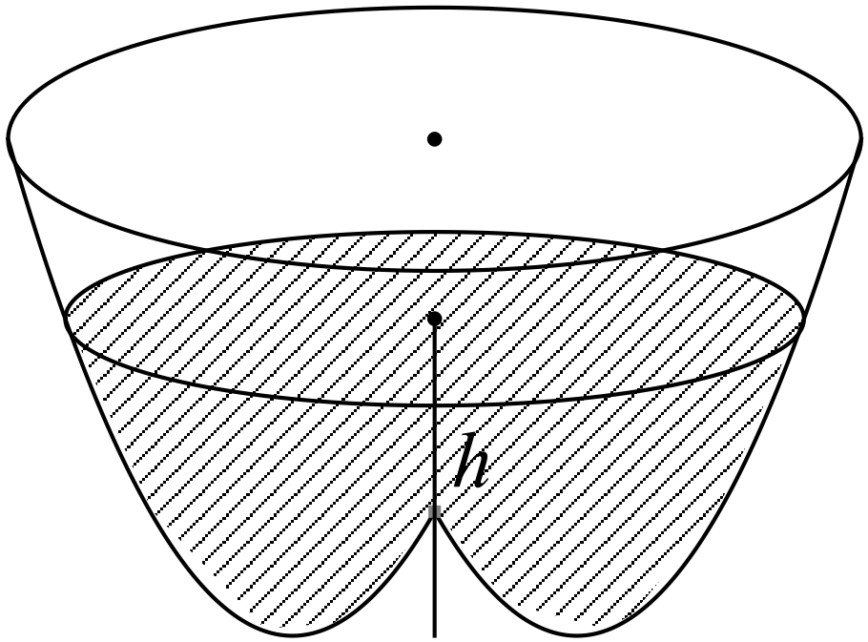
15. (12 marks)
(a) Find the maximum velocity of a particle that is moving in SHM with an amplitude
of 5 and such that 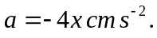 (3)

(b) A cube of side x is slowly increasing.
Use a calculus method to determine the increase in the surface area of the
cube as increases from 10 to 10.1 cm. (3)

(c) Given 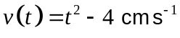 for , 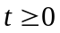and the initial displacement is 3 cm,
determine the acceleration when 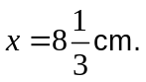 (3)

(d) Given 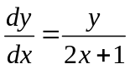 find an expression for in terms of given that (1,3)
belongs to the curve. (3)

16. (5 marks)

(a) Solve the following system of linear equations where possible. If there is more
than one solution, or no solution state why clearly. If there is one solution, find it.

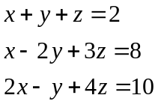 (2)

(b) Use the cross product to determine the area of the triangle AOB in the diagram
below. (3)
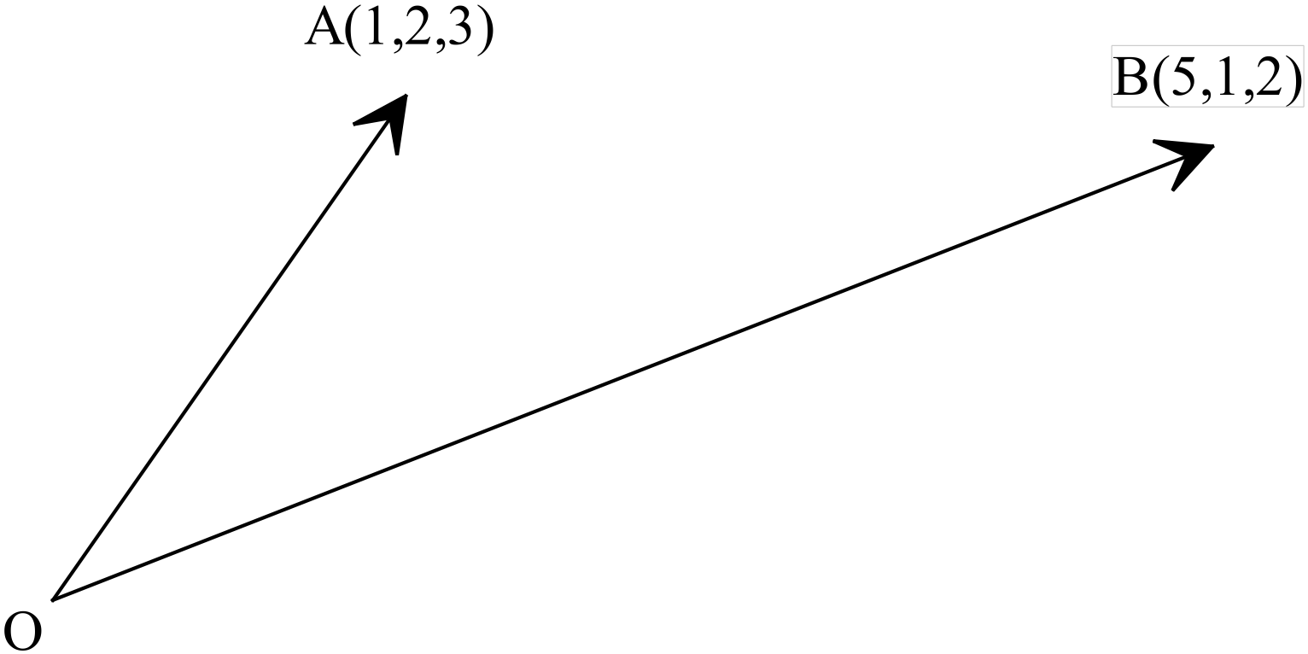

17. (10 marks)

A sample of size 10 was taken from a large population that had an unknown
mean and standard deviation. This was repeated 20 times. The means of the 20
samples (all of size 10) are listed below.

22.3, 23.1, 24.2, 21.5, 22.1, 24.3, 22.5, 23.1, 24.1, 23.1,
24.1, 22.3, 23.7, 23.5, 23.6, 24.2, 22.8, 22.5, 23.7, 24.2

(a) Use the data to determine the values of 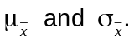 (2)

(b) Use the data to estimate the mean and standard deviation of the
population. (2)

(c) Determine the 95% confidence limits for the population mean. (3)

(d) Find the 99% confidence limits of the mean for the data in (a) and explain the
difference in the two results. (3)

18. (5 marks)
Three large populations have the same mean of 20.
The standard deviations are shown below.
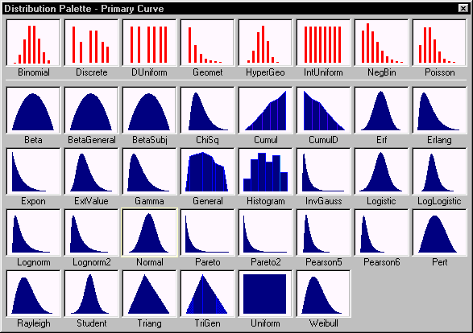
Thirty randomly selected samples each of size 18 are taken from each population and
the means of each sample of the 30 samples are recorded.
Compare and contrast
(i) the means and standard deviation of the sampling distributions
i.e. of the set of 30 means for each population. (4)

(ii) the shape of the sampling distributions. (1)

19. (12 marks)
(a) Given 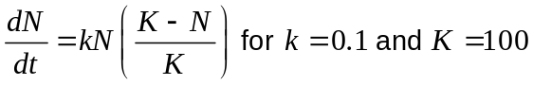 find an expression for  in
terms of and
HINT: Use partial fractions. (5)

(b) The maximum number of trout that can be sustained in a dam is close to 610.
In January 2015, the number of trout was estimated to be 300, and by January
2016, the number had grown to 400.

(i) Use the logistic model to predict the number of trout in the dam in January
2017. (5)

(ii) When will the number of trout reach 600? (2)

20. (6 marks)
Consider the direction graph below.
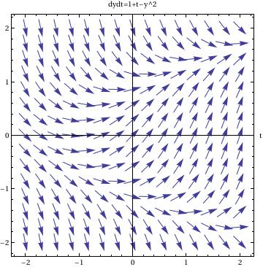
http://www.cfm.brown.edu/people/dobrush/am33/Mathematica/part2.html
(a) Given 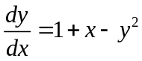 complete the following table and use it to justify the direction field above at . (4)

x | -2 | -1 | 0 | 1 | 2
y | 0 | 0 | 0 | 0 | 0
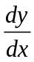

(b) Sketch the graph of the function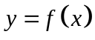that contains the origin on the graph above. (2)

END OF SECTION TWO

